Since the inception of the Games, women have never been allowed to participate in Olympic boxing...until now.

The historic decision of the International Olympic Committee to introduce women’s boxing into the Olympic Summer Games schedule for 2012 is, no doubt, a positive move towards furthering gender equality in sport. Such a move is arguably reflective of improvements in gender equality in the sporting community as a whole.
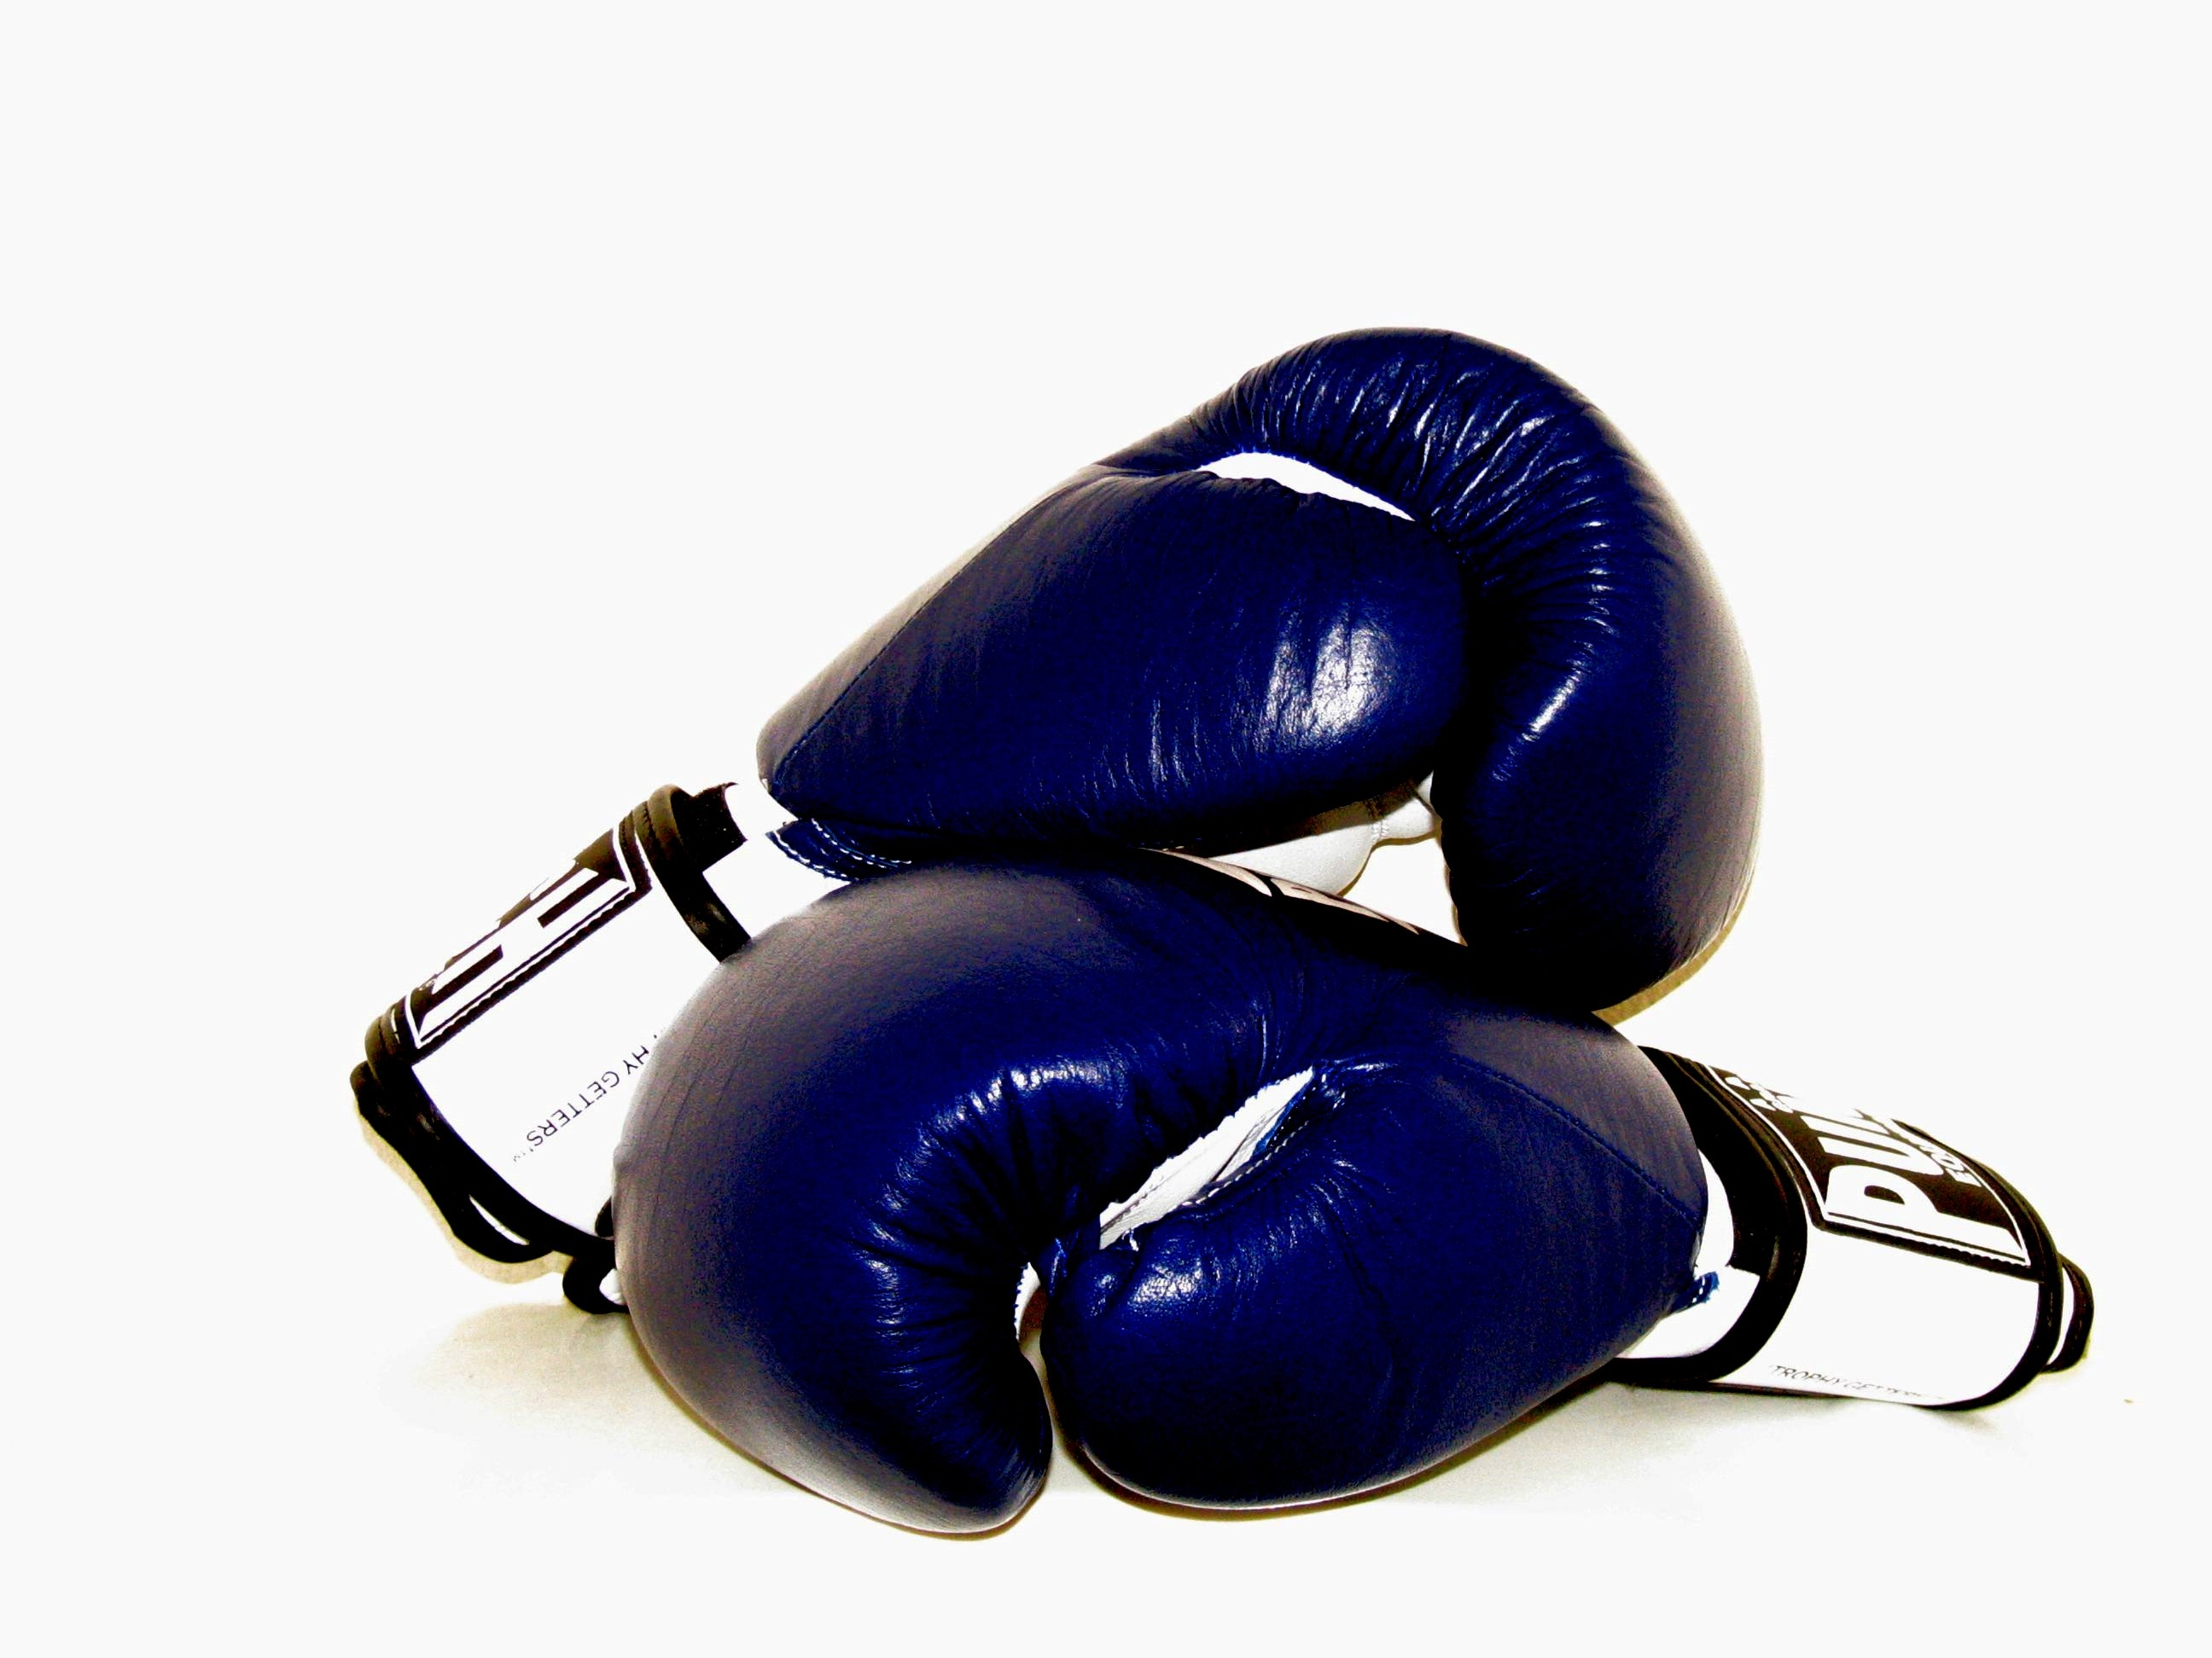
Image created by KayVee.Inc and reproduced under a Creative Commons licence.

WOMEN’S OLYMPIC BOXING

The Executive Board of the International Olympic Committee agreed to the introduction of three women’s events in the 212 Olympic Games. The current 11 men’s boxing events will be replaced by 10 men’s and three women’s events, representing an additional two boxing events on the programme. The total number of boxers remains unchanged.
Image created by Dr John2005 and reproduced under a Creative Commons licence.

The decision was based on recognition that women’s boxing has made substantial progress in universality and technical quality of athletes since the Executive Board of the IOC last met to consider the discipline in 2005.

In the 2012 Games, there will be space for a total of 36 female boxers to compete (compared to a total number of 250 male boxers). This figure, though yet to be officially confirmed, would ensure that the host nation is represented in nearly half of the 13 Olympic categories – 10 for men and three for women. In Beijing, boxing was the only sport on the Olympic programme that women were not allowed to compete in.

Last year, eight British boxers qualified for the 2008 Beijing Olympics, winning one gold medal and two bronzes, the best performance at the Games by GB boxers in 52 years. In addition, many more British boxers might fight their way into the Olympic tournament by performing well in qualifying competitions.
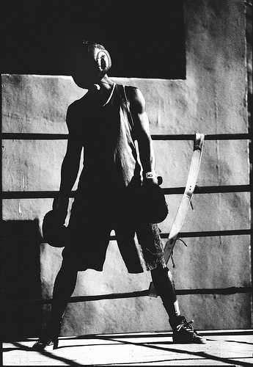

The earmarking of six automatic places for the hosts should ensure that at least one and more likely two of those places will be allocated to female boxers. In fact, with nearly three years to go before the London games, British medal prospects look particularly bright in what will undoubtedly be a landmark women’s boxing competition. For example, bantamweight Nicola Adams recently won a silver medal at the World Championships in China, and light welterweight Natasha Jonas also sits high in the world rankings.

FIND OUT MORE

British Boxing Board of Control
www.bbbofc.com/

Amateur Boxing Association of England
www.abae.co.uk

CREDITS
© Oxford Brookes University 2010. oxb:060111:005dd

This resource was produced as part of the 2012 Learning Legacies Project managed by the HEA Hospitality, Leisure, Sport and Tourism Subject Centre at Oxford Brookes University and was released as an Open Educational Resource. The project was funded by HEFCE and part of the JISC/HE Academy UKOER programme. Except where otherwise noted above and below, this work is released under a Creative Commons Attribution only licence.

Exceptions to the Licence
The name of Oxford Brookes University and the Oxford Brookes University logo are the name and registered marks of Oxford Brookes University. To the fullest extent permitted by law Oxford Brookes University reserves all its rights in its name and marks, which may not be used except with its written permission.

The JISC logo is licensed under the terms of the Creative Commons Attribution-Non-Commercial-No Derivative Works 2.0 UK: England & Wales Licence. All reproductions must comply with the terms of that licence.

The Higher Education Academy logo and the HEA Hospitality, Leisure, Sport and Tourism Subject Centre logo are owned by the Higher Education Academy Limited and may be freely distributed and copied for educational purposes only, provided that appropriate acknowledgement is given to the Higher Education Academy as the copyright holder and original publisher.



Reusing this work
To refer to or reuse parts of this work please include the copyright notice above including the serial number. The only exception is if you intend to only reuse a part of the work with its own specific copyright notice, in which case cite that.

If you create a new piece of work based on the original (at least in part), it will help other users to find your work if you modify and reuse this serial number. When you reuse this work, edit the serial number by choosing 3 letters to start (your initials or institutional code are good examples), change the date section (between the colons) to your creation date in ddmmyy format and retain the last 5 digits from the original serial number. Make the new serial number your copyright declaration or add it to an existing one, e.g. ‘abc:101011:005dd’.

If you create a new piece of work or do not wish to link a new work with any existing materials contained within, a new code should be created. Choose your own 3-letter code, add the creation date and search as below on Google with a plus sign at the start, e.g. ‘+tom:030504’. If nothing comes back citing this code then add a new 5-letter code of your choice to the end, e.g.; ‘:01lex’, and do a final search for the whole code. If the search returns a positive result, make up a new 5-letter code and try again. Add the new code your copyright declaration or add it to an existing one.

